**<https://www.hostinger.com.ua/rukovodstva/ustanovka-lamp-centos-7>**

**Install Apache**

sudo yum update

sudo yum install -y httpd

sudo systemctl enable httpd

sudo systemctl start httpd

ps aux | grep httpd

dig +short myip.opendns.com @resolver1.opendns.com

http://40.118.80.25/

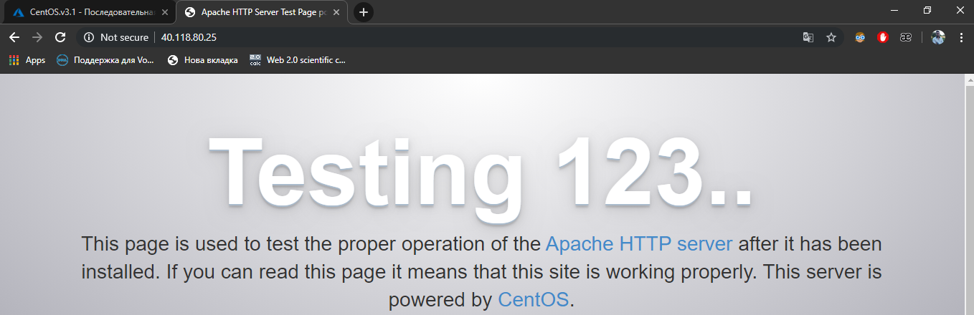

## Install ****MariaDB****

sudo yum install mariadb-server mariadb -y

systemctl start mariadb

sudo systemctl enable mariadb

**Install PHP**

sudo yum install php php-mysql -y

sudo systemctl restart httpd.service

**Testsing PHP**

**Cd /var/www/html**

**Sudo touch info.php**

**Sudo nano info.php**

**<?php**

**phpinfo();**

**?>**

<http://40.118.80.25/info.php>

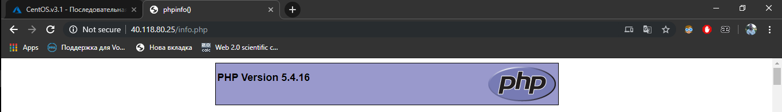

**https://linuxconfig.org/how-to-install-or-upgrade-to-php-7-on-centos-linux-server**

**Updating PHP**

[Alex@centos html]$ php -v

PHP 5.4.16 (cli) (built: Oct 30 2018 19:30:51)

Copyright (c) 1997-2013 The PHP Group

Zend Engine v2.4.0, Copyright (c) 1998-2013 Zend Technologies

sudo wget -q <http://rpms.remirepo.net/enterprise/remi-release-7.rpm>

sudo wget -q <https://dl.fedoraproject.org/pub/epel/epel-release-latest-7.noarch.rpm>

sudo rpm -i remi-release-7.rpm epel-release-latest-7.noarch.rpm

sudo yum-config-manager --enable remi-php71

sudo yum install php

[Alex@centos html]$ php -v

PHP 7.1.32 (cli) (built: Aug 28 2019 13:15:08) ( NTS )

Copyright (c) 1997-2018 The PHP Group

Zend Engine v3.1.0, Copyright (c) 1998-2018 Zend Technologies